Task distribution for ITD x DDA
Step 1: Choosing a theme:
Scenarios:
A: Heritage Brand with Print Commercials:
Objective:
To revitalize existing physical marketing materials using AR by overlaying interactive digital content (animations, videos, product info, etc.) that enhances consumer engagement without the need for reprinting.
- Extend the lifespan and relevance of printed media
- Create immersive brand storytelling experiences
- Encourage users to scan and interact with posters/fliers in public spaces

B: Underutilized Campus Areas:
Objective:
To increase awareness and foot traffic in lesser-known campus locations by allowing users to leave and discover location-based AR notes or emoji reactions, fostering a sense of community and exploration.
- Promote hidden or underused spaces through gamified discovery
- Enable peer-to-peer interaction via virtual messaging
- Encourage campus engagement and social sharing

C: Succulent Collector’s AR Experience
Objective: To educate and engage users in the care of succulents through a virtual gardening experience that blends learning with interaction, making plant care fun and accessible.
- Simulate real-world plant care in a digital environment
- Teach users about different succulent types and their needs
- Foster appreciation for nature and sustainable hobbies

Custom ideas should relate to the broad theme of Personal/Commercial Branding or Education/Training.
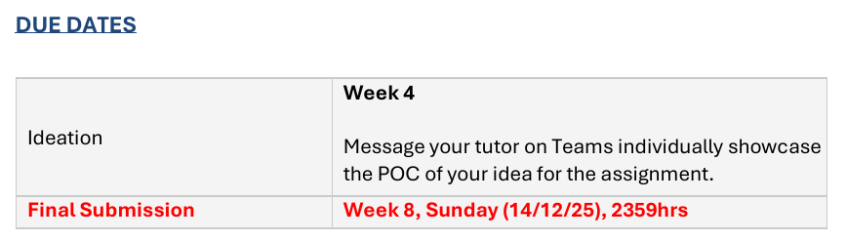

DB (Database)

ITD BASIC MUST-HAVES:
- Must work in Unity editor
- Must have a starting menu
- Must have a clear ending (Players must receive visual notification on completion & be prompted to return to start screen)
- Must use image tracking
- Spawned objects MUST be interactive via UI
- Must have a distinct game objective
- Must show player progression via UI
- Must have visual feedback when the player completes a task
- Models used cannot be primitive shapes (eg. cube, capsule, bean)
- All 3D models MUST be textured.

DDA BASIC MUST-HAVES:
- Must be linked to Google Firebase Realtime database
- Must have a sensible data structure design
- Must be appropriately linked to authentication services
- Must have SOME interaction with Firebase Realtime Database and authentication interactions
- DB JSON file MUST be filled with sample data
- In-game interaction with the DB MUST be shown.

Marks (M)
ADDITIONAL FEATURES: (ITD)
AR Features: (25 M)
- Deployable to Mobile (2M)
- Incorporates plane detection/ face tracking (3M)
- Various forms of interaction between player & AR elements (3M)
- AR objects in the app can interact with each other (5M)
- AR objects are aware when other objects spawn in (5M)
- App can track multiple copies of the same image, one object per image (7M)
UIUX: (10 M)
- Design menu is cohesive & consistent throughout app (3M)
- App has custom assets (2M)
- UI elements are purposefully used & placed (2M)
- App considers mobile screen requirements (3M) Mobile-friendly
Game Juice: (9 M)
- Audio Effects are effectively implemented within the game (3M)
- Game has feedback mechanics (3M)
- Game responds appropriately to player actions (3M)
Promotional Material: (5 M)
- Promo trailer for project (3M)
- Promo Social media posts for project (2M)

ADDITIONAL FEATURES: (DDA)
Feature description (28 M):
- Deployable to mobile (2M)
- Incorporates real-time DB rules & indexes (3M)
- User Auth Issue Handler (5M)
- Sensible frontend web deployment (3M)
- Web portion can be an extension to the app or an admin front end that interacts with Firebase services in real-time (10M)
- Full-fledged end-to-end integration with Web, Unity, & firebase (5M)
UI/X (12 M):
- Shows user-friendly error messages (3M)
- Has seamless fallback mechanism for database/Auth handling (3M)
- UI elements are purposefully placed & used (4M)
- Responsive Web design for web front end (2M)
Promotional Mats (5 M):
Same as ITD but different content?

Deliverables: ITD
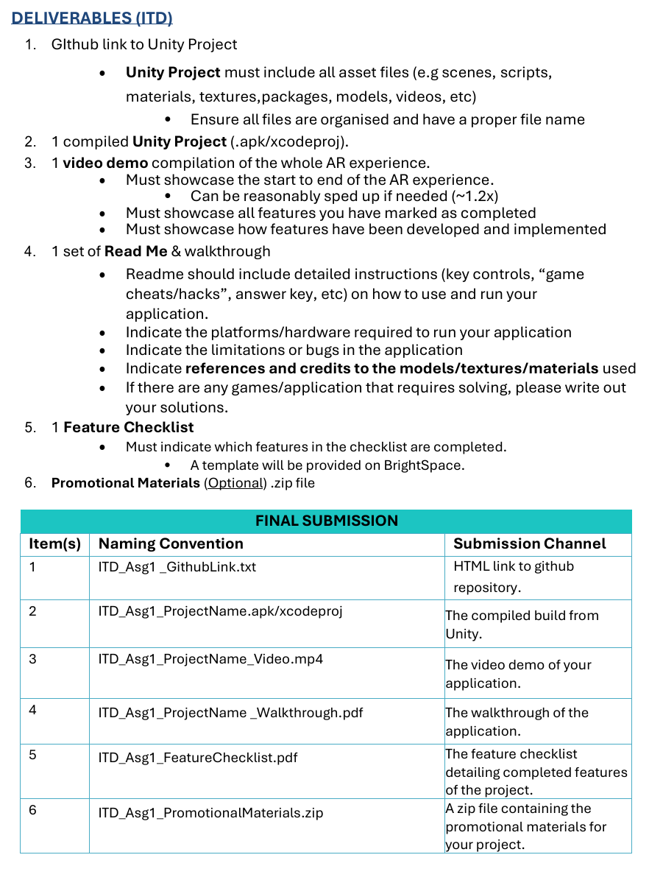

Deliverables: DDA
